Zoning extract

State Environmental Planning Policy (Sydney Region Growth Centres) 2006

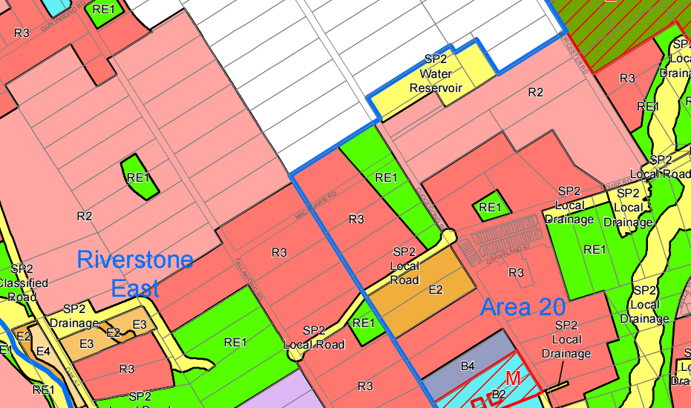

## LEGEND

## Zone

## Subject Land

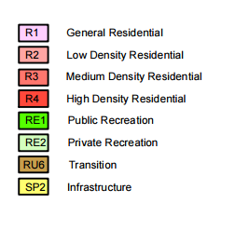

Height of buildings map extract

State Environmental Planning Policy (Sydney Region Growth Centres) 2006

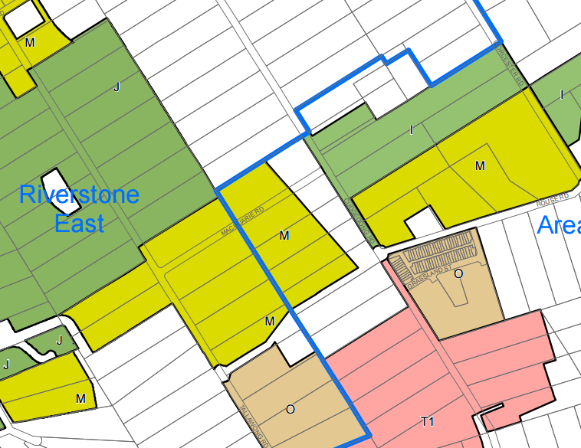

## Subject Land

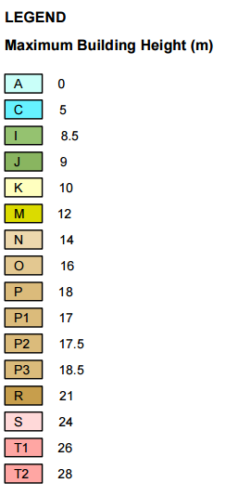

**ILP road pattern map**

